TITLE Justified to the left - HELVETICA 14 PT BOLD

Authors cited with their initials followed by their surnames - HELVETICA 9 pt bold, justified to the left and separated by commas. The presenting author's name is underlined A. García¹, P. Pérez¹
1 Name of the Institution and full address in 8 pt italics justified.
e-mail of the presenting author 8 pt italics justified. agarcia@gmail.com

Please copy this template to your computer and insert the text keeping the format and styles indicated. Use 9 point font size and justified alignment. The length of the text should be a maximum of two pages where the most relevant results of the work will be summarized including relevant references. The presentation of tables, figures and graphics is optional, if they are included follow the indicated guidelines. Abstracts must be written in English [1-3]. Cite references using square brackets.

Guidelines for Figures and Tables

Tables, figures and graphics must be centered, numbered and accompanied by a legend. The figure captions must be below the figures, whilst the table captions must appear above them. All figures and tables must be referenced in the main text. Graphics must be clearly legible, and a maximum of four figures or tables can be inserted in the abstract.

Table 1 - 8 pt bold.  Short description of the table content - 8 pt justified  Catalyst xxxx xxx  Cat1 xx xx  Cat2 xx xx | 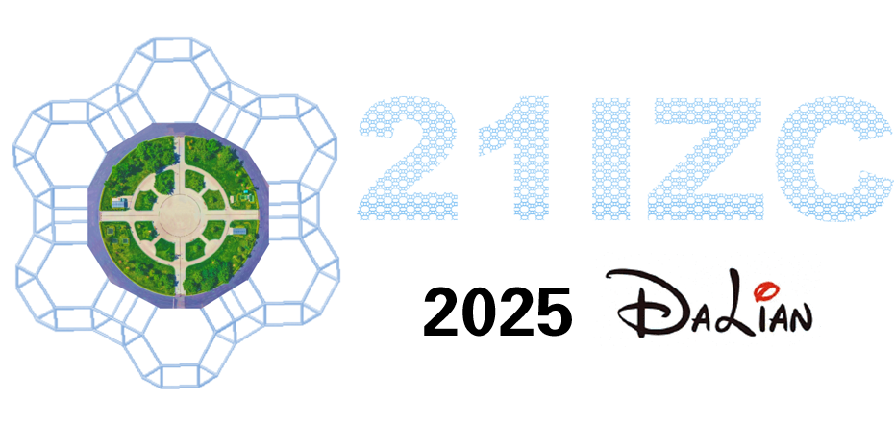  Figure 1 - HELVETIC 8 pt bold.  Figure caption- 8 pt justified

The abstract must be sent through the submission form that you will find on the congress website.
Communications sent by any other means than the submission through the Congress website will not be accepted.

You must send the file in Word format (.doc or .docx).

During the submission process, you must indicate the preferred presentation mode (oral or poster), as well as the topic that best suits the content of the abstract.

You must also indicate who is the contact person for the communication for further notifications and you must indicate who will be the presenting author*.

*Important: Please, keep in mind that each attendee can present a maximum of 2 communications, so each author may only appear as a presenter in two abstracts.

References

[1] A. Author, B. Author, and C. Author, Journal, Volume, Page (Year).
[2] A. Author, Title of Book, Publisher, City (Year).
[3] A. Author and B. Author, Conference, Dates, City, Country, Page (Year).

Aknowledgment – 8 pt, bold
Optional section – 8 pt This work was supported by National Grant no. ….

