A descriptive title
(Times New Roman 16 pt)

Presenting Author¹, One Coauthor^{1,2}, and Another Coauthor² (Times New Roman 13 pt)

¹Affiliation of the author
²Affiliation of the author
E-mail: Presenting.Author@univsound.edu (all Times New Roman 11 pt)

Introduction (Times New Roman 11 pt for section headlines and main text)
In this short introduction to your 2-page abstract for COINT 2024, you should briefly introduce the context of your study. Describe the aim of the work, and mention whether this is an experimental and/or theoretical and/or numerical study. A few references to important the research could be given [1,2]. End by highlighting the most important results.

Length and formatting of the abstract
An abstract for COINT 2024 is limited to two A4 pages with 2-cm-margins on all sides, and written in font size 11 pt. Please use this abstract template for Word. For Word users: The main text is set in "Times New Roman 11 pt", and under "Paragraph" all spacings are set to "0" and "Line spacing" is set to "Exactly" and "At 11 pt". Be careful not to change this during edits.
In terms of contents, the abstract should contain a Title-Authors-Affiliation section in the form and style defined by this template, then a section entitled Introduction as described above, followed by any number of main sections, and ending with two sections entitled Conclusion and References. Besides these few rules, no further restrictions apply.
See Fig. 1 and its sub-figures for an interesting observation [3,4]. A paragraph with more words to explain the results.

A third section headline
A verbose paragraph with more words to explain other results.

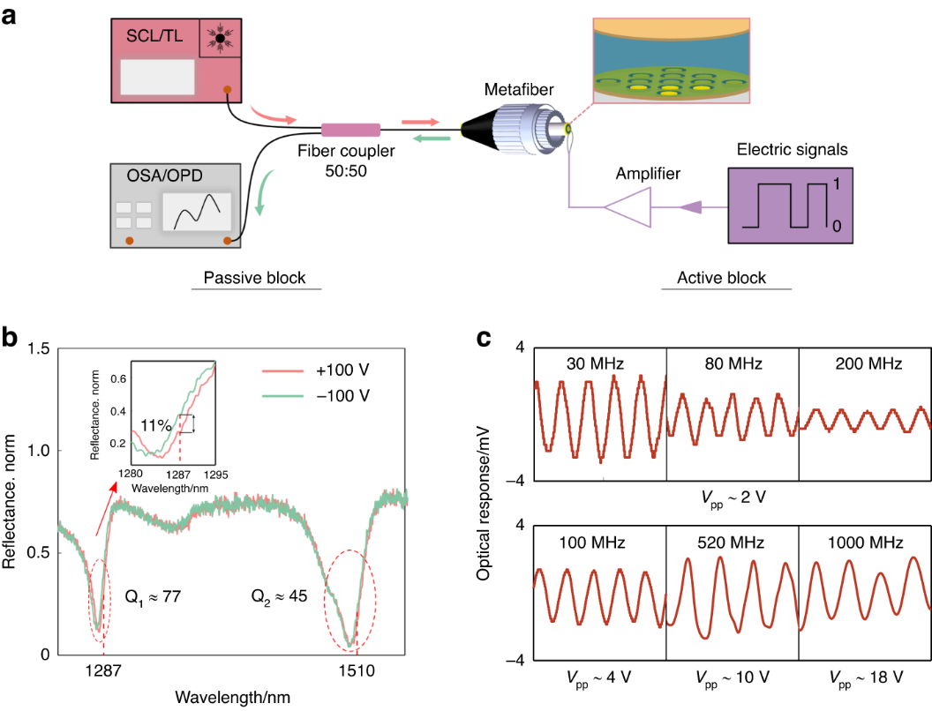
Figure 1: This is an example of a figure which could be up to the full width of the paragraph. It has the figure caption underneath. For Word users: This figure is placed in a 2×1 Table with invisible borders. Be careful not to delete this table environment during edits (Times New Roman 10 pt).

Conclusion
In summary, we have found some amazing results.

References (Times New Roman 10 pt)
[1] P. Author, O. Coauthor, and A. Coauthor. Journal Name 12, 4617-4627 (2012).
[2] O. Coauthor and A. Coauthor. Another Journal 324, 461-512 (2014).
[3] P. Author. A book title, Publishing Company (Publishing City, 2015).
[4] A. Coauthor. Procs. pp. 124-127, Some International Conference, Conference City, 1 - 6 July 2014.

