Template for APCOM-ACCM 2025 Abstract Submission

First/Lead Organiser ^{1*}, Second Organiser ¹ and Third Organiser ¹
¹ Queensland University of Technology, Australia
* Email: corresponding.author@university.edu.au

The abstract should be given here. This should include a brief introduction and statement of the problem, a summary of the background literature, a discussion of the methods used and the main research findings. No acronyms should be used. The maximum length should be 1 page. The authors should include the main equation(s) for their problem or method of analysis, which must be centred with a number flush against the right margin:
$ρ\frac{Du}{Dt}=-∇P+μ∇u+ρg$, (1)
for which all symbols should be defined in the text. For symbol handling, it may be possible to use different symbol fonts or equation editors with this template, but this is not guaranteed. It is also possible (but not essential) to include one small figure or one small table, without caption text:

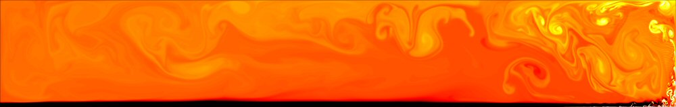
Figure 1.
Mesh | No. of cells | $$C_{D}$$ | $$C_{L}^{'}$$ | $$St$$
M1 | 16,192 | 1.538 | 1.034 | 0.245
M2 | 64,792 | 1.546 | 1.053 | 0.241
M3 | 261,600 | 1.547 | 1.064 | 0.239

Table 1.
It is also possible (but not essential) to include a small number of references, which should be hand-numbered [1]. These are provided in the initial submission to assist the reviewers, but will need to be removed from the published version. Up to six keywords (or phrases) must also be given – these will be used to guide the selection of reviewers.

Keywords: Navier-Stokes equations, boundary-layer flows, conservation laws, machine learning, entropy production

References

[1] Schlichting, H., Boundary-Layer Theory, 6th ed.; McGraw-Hill: NY, USA, 1968.

