**Two-Step Approach for Optimizing Flexure-Based Mechanisms:**

**A Displacement Amplifier Case Study**

#### Guimin Chen, Yu Cheng, Ruiyu Bai , and Bo Li

#### (State Key Laboratory for Manufacturing Systems Engineering and Shaanxi Key Lab of Intelligent Robots, Xi’an Jiaotong University, Xi’an 710049, China

#### (e-mail: guimin.chen@xjtu.edu.cn)

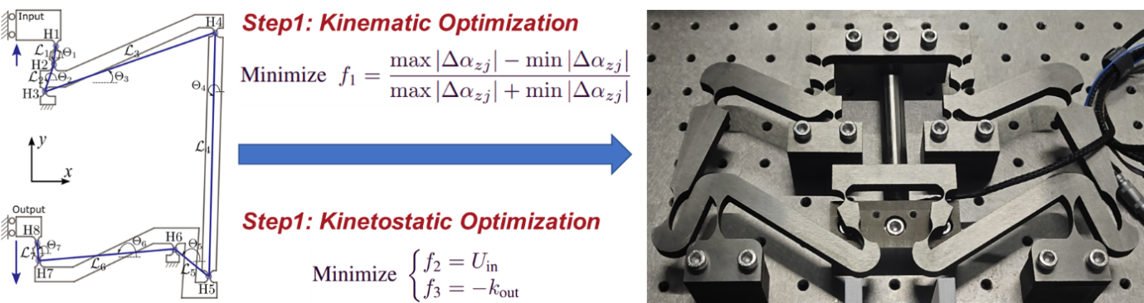

#### **Abstract:** A flexure-based compliant mechanism achieves its motion from the deflection of its flexure hinges, offering many advantages, such as increased precision and reduced wear and backlash. Because the motion comes from the deflections of flexure hinges, the strain energy stored in the deflected flexure hinges consumes considerable energy being transmitted from the actuator, and the stress concentrations at the thinnest cross sections of the flexure hinges make them the most vulnerable parts. Appropriately allotting the deflection amplitude and the compliance of each flexure hinge in a flexure-based mechanism are crucial for achieving the demanding design goals. In a flexure-based mechanism, different flexure hinges may be subject to totally different loads and undergo diverse deflections. For example, in a two-stage displacement amplifier, the flexure hinges in the first stage often undergo very small deflections, whereas those in the second stage bear very large deflections. To use identical flexure hinges for the whole amplifier could simplify the design process but always results in poor performances including lower transmission efficiency and shortened fatigue life. To select optimal design for each of the flexure hinges always leads to a high-dimensional optimization problem involving a large number of tuning parameters (including the geometric parameters and the orientations of each of the flexure hinges and the dimensions of the amplifier), which could be computationally prohibitive for optimization.

The contribution of this work is that a two-step optimization approach is proposed for optimizing flexure-based mechanisms, which decomposes the high-dimensional optimization problem into two low-dimensional subproblems (with one to allot the deflection amplitude and the other to allot the compliance). The two low-dimensional subproblems are relatively independent and can be tackled separately. The first step is a dimensional optimization of the mechanism in which the optimal placements of the flexure hinges are determined so as to minimize the angular deflection differences of flexure hinges while ensuring the design requirements (for example, the amplification ratio). Minimization of the angular deflection differences helps to allocate the deflections more evenly throughout the mechanism and improve energy transmission efficiency (noting that the main strain energy in each flexure hinge is of the quadratic form of the angular deflection). We call this step the kinematic optimization considering that the load-deflection relations of the flexure hinges are neglected, and a coarse model that captures the kinematics of the mechanism is enough. Based on the mechanism obtained in the first step, the second step tunes the geometric parameters and the orientations of the flexure hinges so as to lower the strain energy (improve transmission efficiency) while enhance the output stiffness. In this step, a fine kinetostatic model considering the load-deflection relations of each flexure hinge is required, thus we call it the kinetostatic optimization. By utilizing the generalized flexure models in the kinetostatic model, we are able to incorporate different types of flexure hinges in the kinetostatic optimization.

The effectiveness of the two-step optimization approach is demonstrated on the tensural two-stage displacement amplifier. Besides ensuring the amplification ratio to guarantee the output stroke, we optimize the amplifier by minimizing the deflection angle differences of flexure hinges, lowering the total strain energy stored in the flexure hinges so as to improve the transmission efficiency, increasing the output stiffness so as to guarantee the effective actuation, and ensuring that the stress level in the flexure hinges is within the allowable stress of the material. As compared with the original design, both the transmission efficiency and the output stiffness are significantly improved after the two-step optimization with almost the same amplification ratio. In general, the proposed two-step optimization approach can be tailored for optimizing various flexure-based mechanisms with different design objectives

#### **Key words:** Displacement amplifier; optimization approach; flexure-based mechanism

**Attendee Information:**

|  |  |
| --- | --- |
| **Speaker/Title** | Guimin Chen (陈贵敏)/Prof. |
| **Title of Report** | Two-Step Approach for Optimizing Flexure-Based Mechanisms: A Displacement Amplifier Case Study |
| **Preferred Session** | Compliant Mechanisms Synthesis 🞏  Theoretical Modeling of Compliant Mechanisms 🞏  Design Methodology of Compliant Mechanisms 🗹  Topology Optimization of Compliant Mechanisms 🞏  Compliant Multistable Mechanisms 🞏  Compliant Constant-Force Mechanisms 🞏  Compliant Amplifier/Reducer 🞏  Compliant Origami Mechanisms 🞏  Compliant Metamaterials 🞏  Compliant/Soft Robotics 🞏  Compliant Medical Devices 🞏  Applications of Compliant Mechanisms 🞏  Others 🞏 |
| **Preferred Language** | Chinese🞏 English🗹 |
| **Poser Interaction** | Yes🗹 No🞏 |
| **Speaker Bio** | **Guimin Chen** is a Full Professor of Xi’an Jiaotong University. He had been working as a visiting professor at Compliant Mechanism Research Lab of Brigham Young University. His major research interests include compliant mechanisms and their applications in robotics. He was the recipient of 2018 ASME Compliant Mechanisms Award. He serves as an Associate Editor of ASME Letters in Translational Robotics, and served as an Associate Editor of IEEE Transactions on Automation Science and Engineering and ASME Journal of Mechanisms and Robotics. He is also a Fellow of ASME. |

**(Please send this to iccm2025@163.com before March 10, 2025)**